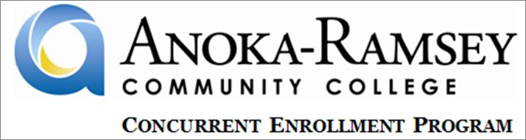

2013-2014 Academic Year

Dear Concurrent Enrollment Program Student,

Welcome to Anoka-Ramsey Community College’s Concurrent Enrollment Program! I am thrilled to welcome you to the beginning, or continuation, of your college career at Anoka-Ramsey Community College.

Students taking Concurrent Enrollment Program courses through Anoka-Ramsey Community College have the same level of access to learning resources and are beholden to the same rules, policies, and procedures as all other students. Students taking Concurrent Enrollment Program courses are held to the same standards of achievement as those expected of students enrolled in on-campus sections. Grading standards are also the same as those used in on-campus sections at Anoka-Ramsey Community College’s two campuses.

Students are expected to follow all rules, policies, and procedures that pertain to Anoka-Ramsey Community College students. All of these rules, policies, and procedures are found in the Student Code of Conduct. Please review the Student Code of Conduct here: <https://www.anokaramsey.edu/en/about/Information/Policies/Chapter3/3F1.aspx>.

Students are also encouraged to use the 2014-2015 Anoka-Ramsey Student Planner. Copies are available, free of charge on campus, and available online here: <http://www.anokaramsey.edu/en/resources/studentInfo/~/media/Files/Resources/Student%20Planner/2012%20Student%20Planner%20WEB.ashx>.

As an official Anoka-Ramsey Community College student, you are starting an official college transcript that will be a permanent part of your postsecondary educational record. The course(s) that you are taking are college-level, rigorous, and demanding. The expectations of you, as a college student, are to perform at the college-level. Students taking college classes in their high schools are held to the same standard of achievement as those expected of students taking classes on the Anoka-Ramsey Community College campus.

To access the many resources available to you as an Anoka-Ramsey Community College student, and to learn more about our Concurrent Enrollment Program, please visit our website. You can find a comprehensive listing of student and academic resources available to you at Anoka-Ramsey Community College’s website, [www.anokaramsey.edu](http://www.anokaramsey.edu). Please use these resources and services, many of which are accessible online and available 24 hours a day. These will help you achieve academic success in your Anoka-Ramsey Community College Concurrent Enrollment Program course.

At our Concurrent Enrollment Program website ([www.anokaramsey.edu/classes/concurrentenrollment.aspx](http://www.anokaramsey.edu/classes/concurrentenrollment.aspx)), you can find the 2014-2015 Concurrent Enrollment Program Student Manual. The 2014-2015 Concurrent Enrollment Student Manual contains information pertinent to Anoka-Ramsey Community College’s Concurrent Enrollment Program. This manual contains an introduction to ARCC’s Concurrent Enrollment Program, information about ARCC academic services available to all students, and policies, procedures, and practices relevant to you as a Concurrent Enrollment Program student.

Provided with this letter is a document detailing many of the academic and student services available to you as an Anoka-Ramsey Community College student. Please review these services, from advising to transfer options, and academic resources, from the libraries to online tutoring, and use them as often as needed. Please access them online or come to one of our campuses to use these resources.

Along with the information and services available to you at Anoka-Ramsey Community College and in the 2014-2015 Concurrent Enrollment Program Student Manual, never hesitate to contact your High School Counselor or Dean, your Concurrent Enrollment Program Teacher, or Anoka-Ramsey Community College for assistance. We are more than happy to answer any questions, steer you in the right direction, or explain other Concurrent Enrollment Program course options that may be available to you at your high school.

Best of luck this academic year!

Sincerely,



Michael J. Werner

Anoka-Ramsey Community College